Epic Prelude / HIM Workflow Simulation – OpenEMR
Tools Used: OpenEMR (EHR Simulation), Microsoft Word
Skills Demonstrated: Workflow Analysis, Documentation, Data Integrity Validation

Section 1 – Project Summary
This project simulates the patient registration and documentation workflow found in Epic Prelude and Health Information Management (HIM) modules. Using OpenEMR, I created mock patient records, scheduled appointments, and documented encounters to mirror real EHR processes. The workflow covered demographic entry, insurance verification, visit scheduling, encounter documentation, and reporting, demonstrating how accurate intake data flows through clinical and administrative systems. The project strengthened my understanding of end-to-end EHR workflows, patient data integrity, and documentation accuracy within healthcare information systems.

Step 1: New Patient (Demographics)

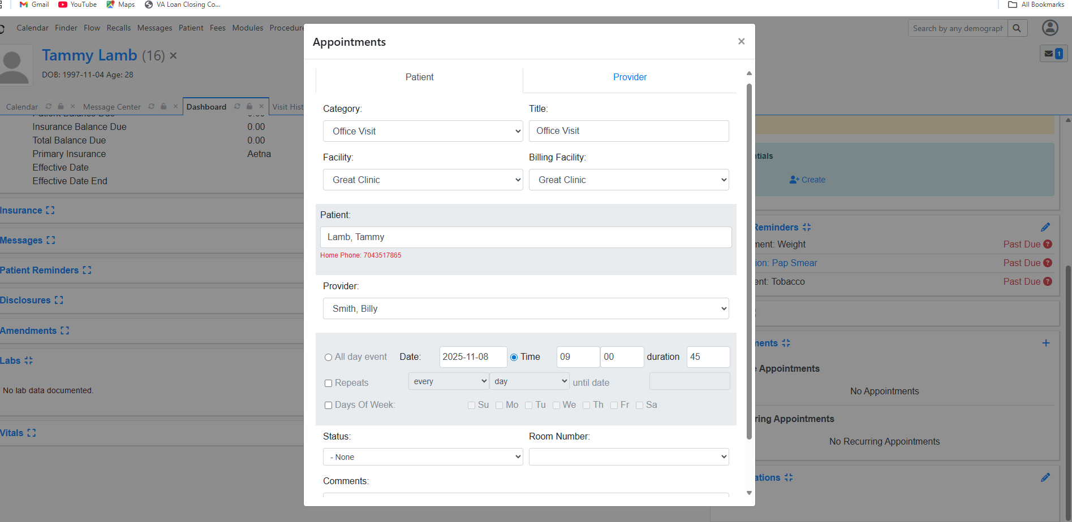
Demonstrates creation of a new patient record in OpenEMR, mirroring the Epic Prelude registration process. Includes entry of demographics, insurance details, and contact information to ensure accurate data capture at intake.

Step 2: Appointment Calendar View

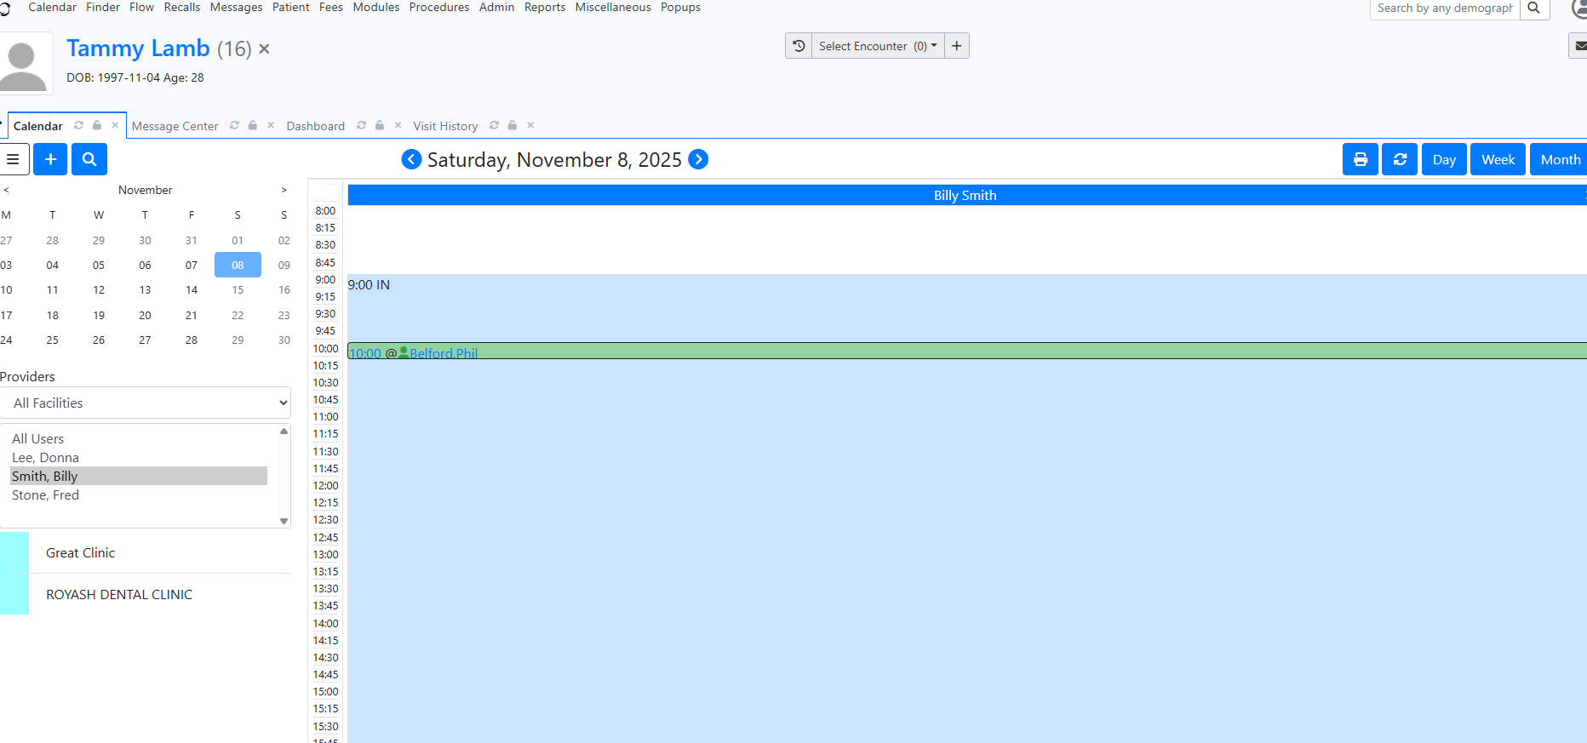

Shows how a new patient visit is scheduled and assigned to a provider using OpenEMR’s calendar system. This simulates the Epic Prelude scheduling workflow where registration data connects to the visit record.

Step 3: Encounter Documentation (Office Visit)
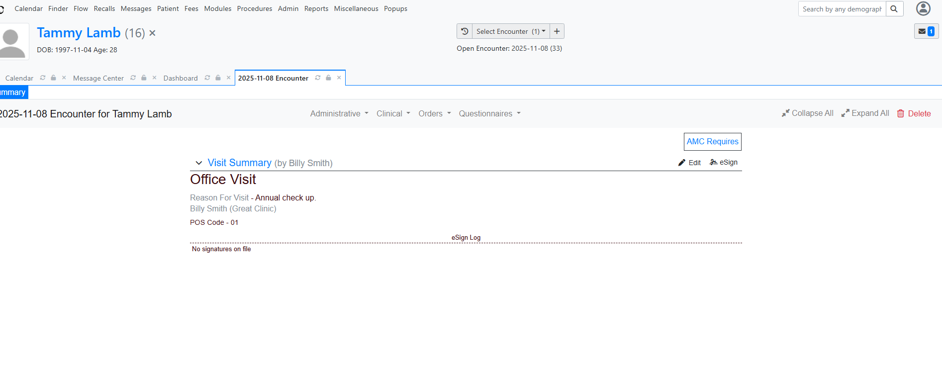

Displays the Office Visit encounter for the patient, representing the Epic HIM module’s documentation process. Clinician notes, visit reasons, and provider information are entered and saved as part of the medical record.

Step 4: Visit History Report

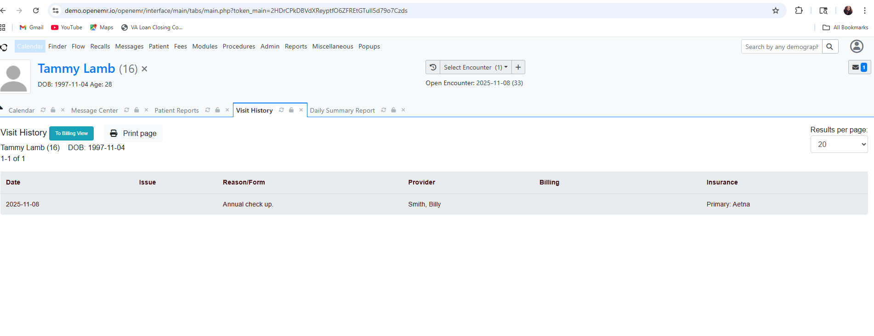
Provides a summary report of all encounters for the patient, including visit date, reason, provider, and insurance. Reflects the HIM reporting workflow used to verify visit accuracy, data completeness, and patient history.

